Agribot: Plantation and AI Driven Quality Insights

Vaibhav Nrupnarayan   
*Dept. of Electronics and Tele-Communication Engineering  
 G H Raisoni College of Engineering and Management  
 Pune, India.*  
vaibhavnrupnarayan2021@gmail.com  
  
Abhiman Bade  
*Dept. of Electronics and Tele-Communication Engineering  
 G H Raisoni College of Engineering and Management  
 Pune, India.*  
abhimanbade9763@gmail.com  
  
  
Harish Bagul  
*Dept. of Electronics and Tele-Communication Engineering  
 G H Raisoni College of Engineering and Management  
 Pune, India.*  
harishbagul1816@gmail.com  
  
  
Kavita Joshi  
*Dept. of Electronics and Tele-Communication Engineering  
 G H Raisoni College of Engineering and Management  
 Pune, India.*  
kavita.joshi@raisoni.net

Mohd Salman Khan  
Assistant Professor (Senior Grade), Dept. Of ECE,   
*JIIT Noida,*Noida, India  
salman.khan@jiit.ac.in

*Abstract*— The Agribot: Plantation and AI Driven Quality Insights project presents an innovative solution to modernize rice farming by integrating Machine Learning (ML) and Internet of Things (IoT) technologies to automate rice planting, environmental monitoring, and crop management. Traditional rice cultivation is labour-intensive, time-consuming, and prone to inefficiencies, resulting in higher costs, inconsistent planting, and reduced yields. The Agribot is designed to address these challenges by precisely planting rice seedlings, monitoring plant growth, and evaluating crop health using advanced image processing techniques. By continuously collecting real-time data on plant conditions through camera, the system enables data-driven decision-making to improve crop quality, and enhance yields.

AI-driven algorithms allow the Agribot to make intelligent decisions, such as detecting and responding to environmental changes, identifying plant diseases, and managing weeds, thereby improving overall farm management. The system reduces reliance on manual labour, increases planting accuracy, and enhances productivity, making farming more efficient and profitable. This project holds the potential to transform agricultural practices by fostering precision farming techniques, ultimately contributing to food security and sustainable agricultural development. By modernizing rice farming, the Agribot can lead to significant advancements in crop production, benefiting both farmers and the agricultural industry.

Keywords—Crop disease detection, Rice crop plantation, Machine Learning, Hardware- Raspberry Pi, Ultrasonic Sensor, Camera.

# Introduction

Agriculture is an essential pillar of the global economy, feeding billions and sustaining livelihoods, with rice serving as a staple crop for over half the world's population. Yet, the sector faces significant challenges, particularly in rice farming, where traditional practices rely heavily on manual labour. These methods are labour-intensive, time-consuming, and prone to inconsistencies, leading to suboptimal yields and inefficient resource use. Additionally, the lack of early detection systems for crop health problems results in avoidable losses and a lower overall quality of produce. With the rise in global food demand and labour shortages, there is an urgent need for innovation in farming techniques to ensure productivity, sustainability, and scalability. This is where the Agribot: Plantation and AI Driven Quality Insights comes in—a transformative solution that integrates advanced robotics, artificial intelligence (AI), and Internet of Things (IoT) technologies to revolutionize rice farming. The Agribot automates the entire rice planting process, ensuring precision and uniformity while significantly reducing labour costs. One of the Agribot's core features is its ability to monitor crop health using high-resolution imaging and AI-driven analysis. The system uses machine learning models to identify potential health issues, such as diseases or nutrient deficiencies, in their early stages. By providing actionable insights, it allows farmers to address these issues proactively, thereby improving yield quality and quantity. The Agribot's need arises from a confluence of challenges: increasing food demand, dwindling agricultural labour, and inefficiencies in traditional farming methods. By leveraging cutting-edge technologies, the Agribot addresses these issues, providing a sustainable, efficient, and cost-effective alternative to conventional practices.[1][4][5]

This project is not just about mechanization but also about enabling smarter farming through data-driven decision-making. It integrates automation with AI capabilities, making rice farming more predictable and resource-efficient. The Agribot’s modular design and adaptability allow it to cater to varying field conditions and farmer needs, ensuring its applicability in diverse agricultural environments. The Agribot: Plantation and AI Driven Quality Insights represents a pivotal step toward modernizing agriculture. It combines precision, intelligence, and sustainability to overcome traditional farming challenges, making it a valuable tool in addressing global food security. By automating labour-intensive tasks, enhancing crop quality, and optimizing resource use, the Agribot paves the way for a smarter, more resilient agricultural future.[7]

# Literature Survey

One study discusses the development of a robot tractor equipped with technologies like RTK, GPS, and IMS for precise navigation, which not only turns the soil but also functions as a rice planter. This system uses the Can Bus protocol for real-time communication, improving efficiency and allowing the robot to work autonomously in the field.

Another approach utilizes a crank-shaft mechanism for continuous seeding, achieving a high accuracy rate of 92% and reducing the time required for manual labour. The four-wheel design ensures ease of movement, while the Prototype battery life of up to two hours enhances its operational efficiency.

Cloud-based data management is another aspect explored in the literature. Sensors connected to microcontrollers upload data to the cloud, allowing for real-time analysis and monitoring of crop health. This enables farmers to make informed decisions about crop management, enhancing productivity.

The use of AI in agriculture has also been a focus, particularly for detecting plant diseases and quality assessment. Techniques like image processing and neural networks have been applied to identify crops, evaluate quality, and detect diseases based on texture and colour features. For instance, using CIELAB colour models and Artificial Neural Networks (ANNs), systems can classify and identify unhealthy regions of plant leaves, enhancing precision in disease detection.

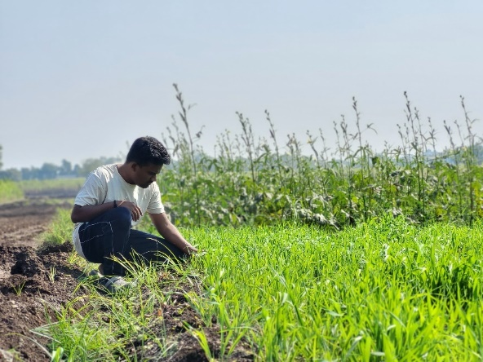Navigation algorithms, crucial for autonomous agricultural systems, are also highlighted. Capacitive touch sensors and azimuth sensors guide robots in complex environments such as uneven fields or terraced paddies, ensuring accurate planting even in challenging conditions.

These studies provide foundational insights that drive the development of the Agribot: Plantation and AI Driven Quality Insights, emphasizing the integration of robotics, Machine Learning and IoT to revolutionize rice farming by automating labour-intensive processes and enhancing crop quality control.

# Problem Identification

The problem of rice cultivation is multifaceted, particularly due to its labour-intensive nature and challenging environmental conditions. Traditional rice planting methods require significant manual effort, often leading to inconsistent planting, increased labour costs, and inefficient use of resources. Moreover, farmers face dangers from hazardous insects and snakes commonly found in rice fields, further complicating labour availability. This results in increased operational costs and reduced overall efficiency in farming practices.

Another critical issue is the inconsistent quality control of rice crops, which negatively impacts market value and consumer trust. Ensuring consistent, high-quality rice production is difficult without advanced quality monitoring and management systems. Addressing these problems requires an innovative approach that reduces reliance on manual labour, improves planting precision, and enhances crop quality through real-time monitoring and intelligent decision-making. The Agribot aims to resolve these challenges by automating the rice planting process, integrating ML-based quality control measures, and ensuring safer and more efficient agricultural practice.

# Survey

A critical part of the development framework for the Agribot: Plantation and AI Driven Quality Insights was the comprehensive field visit to a rice farm, which provided invaluable insights into the practical challenges and conditions faced by farmers. This visit allowed the team to closely observe and understand the limitations of traditional rice planting methods, such as inconsistent seedling placement, inefficient spacing, and the heavy reliance on manual labour. The team witnessed firsthand how these issues lead to suboptimal yields, wastage of resources, and increased operational costs. During the visit, extensive data was collected on various aspects of the farming process. The layout of the field was studied to understand the spatial challenges, such as uneven terrain and varying plot sizes, which impact the precision of planting operations. The team also evaluated crop health monitoring techniques, identifying the gaps in traditional methods and the potential for advanced imaging and sensor-based solutions.

Conversations with farmers further enriched the understanding of their day-to-day struggles, including the unpredictability of labour availability, time constraints, and the need for consistent planting quality. These discussions highlighted the urgency for a solution like the Agribot, capable of automating planting processes while offering reliable performance in diverse agricultural conditions.

The field visit not only validated the potential benefits of automation in real-world agricultural settings but also shaped 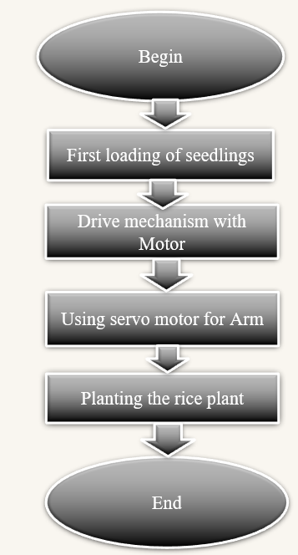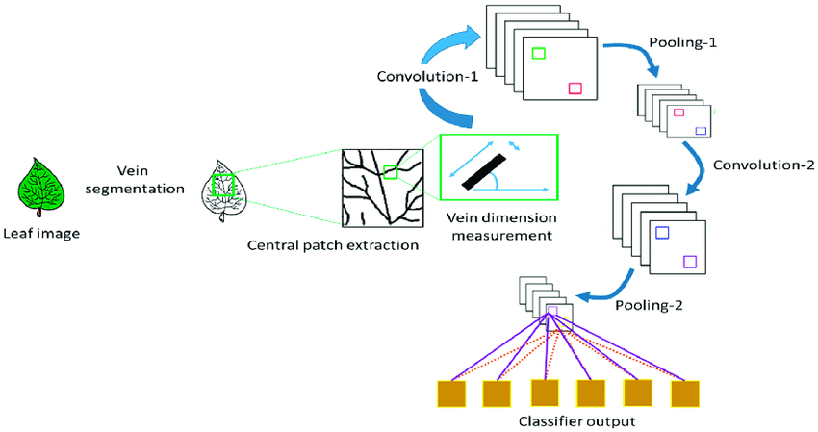the design and functionality of the Agribot. By addressing specific needs identified during the visit, such as precise seedling placement, adaptability to varying field conditions, and real-time health monitoring, the Agribot was tailored to provide practical, efficient, and sustainable solutions for farmers. This immersive survey reinforced the importance of integrating technology with traditional farming practices to enhance productivity and sustainability.

# Plantation Process

The plantation process using the Agribot begins with the robot preparing the field for systematic coverage. The robotic arm, picks up rice seedlings from a storage tray and places them into the soil at predefined intervals and depths. This ensures uniform planting, optimizing space and nutrient utilization for better growth. These data points allow the Agribot to adapt its operations dynamically, ensuring optimal planting conditions.

Simultaneously, the Agribot captures high-resolution images of the planted seedlings using its camera system. These images are processed using machine learning algorithms to assess the health and placement of each seedling, identifying any potential issues such as missing plants or inadequate spacing. Any detected irregularities are logged and reported to the farmer via a dashboard for corrective action. This automated planting process minimizes labour dependency, ensures consistency, and optimizes resource utilization. By integrating robotics, AI, and IoT, the Agribot: Plantation and AI Driven Quality Insights transforms rice farming into a streamlined, efficient, and precision-driven operation, promoting higher yields and sustainable agricultural practices. The methodology for the Agribot: Plantation and AI Driven Quality Insights project follows a structured approach to developing an autonomous rice planting system by integrating hardware, software, and advanced Machine Learning and IoT technologies. The process begins with system design, where the overall architecture is conceptualized, focusing on mobility, planting precision, and monitoring of plant health. The mechanical structure, including the drive mechanism and a robotic arm with a 180 degree rotating arm mechanism for precise seedling planting, is laid out. Key hardware components such as DC motors, motor controllers, and sensors are assembled, with a Raspberry Pi acting as the central control unit. Image processing is handled through a camera system, enabling health monitoring of crops.[7][5]

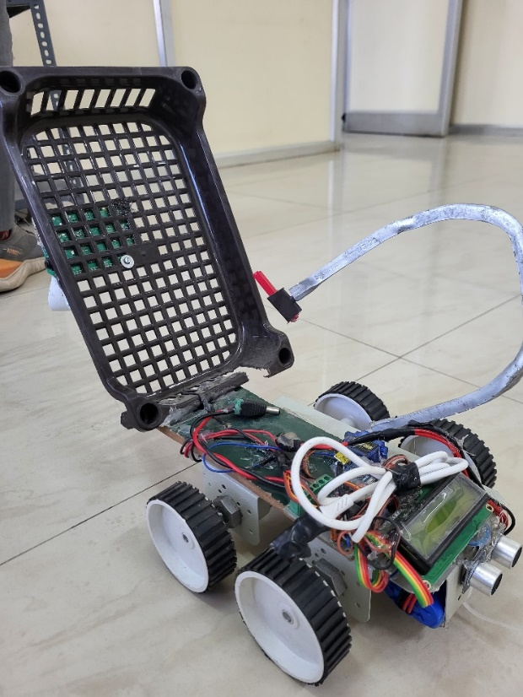On the software side, control algorithms are developed for motor coordination and sensor data acquisition, with machine learning algorithms implemented for image processing and plant health detection. The software also provides a dashboard for real-time monitoring of environmental conditions and alerts for any issues. The testing phase includes both controlled and field tests to fine-tune the hardware and software and assess the system’s performance in real-world farming conditions. Comprehensive documentation is maintained throughout the 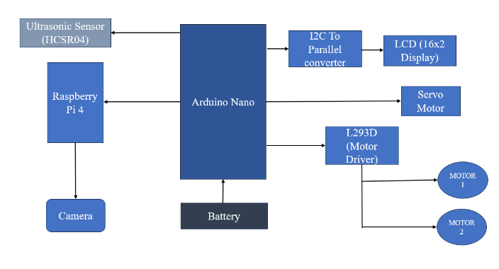development process, ensuring that the system’s design, testing, and results are well-recorded. This methodology integrates advanced technology with practical agricultural needs, optimizing rice farming through automation and AI-driven insights.[1][2]

# Software Frameworks and Model Accurecy

1. Python Programming: Used for control algorithms, sensor data processing, and implementing IoT functionalities. Facilitates communication between hardware components via libraries like RPi, GPIO.

2. TensorFlow and Keras: Machine learning frameworks for building and training neural networks for image-based crop health analysis. Support feature extraction and disease detection with convolutional neural networks (CNNs).[13]

3. OpenCV: A powerful library for image processing and computer vision.: Used for tasks such as preprocessing captured images, feature segmentation, and detecting crop irregularities.

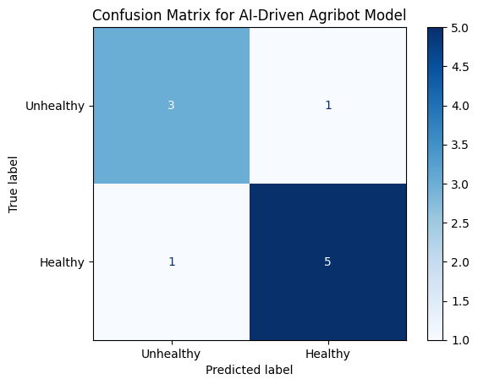

Figure 5 Confusion Matrix for CNN Model

The accuracy of the Agribot Machine Learning model will be calculated by evaluating its predictions against the actual ground truth labels from a test dataset. Accuracy is defined as the ratio of correctly predicted observations to the total number of observations. It provides a straightforward measure of the model's overall performance. Mathematically, it is calculated as:

**Accuracy = (True Positives + True Negatives) / (Total Observations)**

In this context, the model’s predictions on crop health (e.g., healthy or unhealthy) will be compared to the labeled data. To compute accuracy, the total number of correct predictions (both healthy and unhealthy classifications) will be divided by the total number of test samples. Additionally, the model's performance will be validated using a confusion matrix, which provides detailed insights into true positives, true negatives, false positives, and false negatives. This ensures that the model's accuracy not only reflects the correct classifications but also highlights any biases or errors in specific categories.[9][10][13]

A Machine Learning (ML) model based on a Convolutional Neural Network (CNN) that uses a masking method to detect shades in green and red colours is likely designed for applications such as plant health monitoring, leaf disease detection, or agricultural crop analysis. Here is a detailed description of such a system:

1. Input Data: The system typically takes high-resolution images of leaves or plants as input. These images are pre-processed for noise reduction and normalized for consistent analysis.

2. Preprocessing with Masking:

* Colour-Based Masking: A masking technique is applied to filter out specific shades of green and red from the image.
* Green Shades: Indicates healthy plant tissue.
* Red Shades: Often associated with diseased or stressed areas in plants.

Thresholding: Specific thresholds for the red and green colour channels are defined in the HSV (Hue, Saturation, Value) or RGB colour space. These thresholds isolate pixels corresponding to the desired shades, creating a binary mask. The binary mask is overlaid on the original image to retain only relevant regions for analysis, reducing computational complexity and focusing the CNN on critical areas.[13]

3. CNN Architecture: The CNN is trained to classify and analyse the segmented image regions:

* Feature Extraction Layers: Initial convolutional layers detect patterns such as textures, edges, and colour variations specific to healthy and unhealthy regions.
* Pooling Layers: Down-sample the extracted features while retaining essential spatial information.
* Fully Connected Layers: Combine the features to predict the health status or disease class of the plant.

4. Mask Integration in Training: The masked regions guide the CNN to focus on areas that are likely to contain meaningful information (e.g., affected spots on a leaf), improving the accuracy of predictions. The masking step reduces noise caused by irrelevant background features, such as soil, sky, or non-plant objects in the image.[15]

# Acknowledgment

It gives us great pleasure in presenting Agribot: Plantation and AI Driven Quality Insights as our B.Tech. project. Words have never seemed as inadequate as now when we are endeavouring to express our gratitude at the culmination of our B.Tech. Project to all those who have made it possible. Even the best efforts are waste, without the proper guidance and advice of our project guide Dr. Kavita Joshi for the consistent guidance, co-operation, inspiration, practical approach, and constructive criticism, which provided us the much-needed impetus to work hard & also thanks Dr. S. K. Waghmare Head of E&TC Department for their continuous support & valuable suggestions.

We take this opportunity to thank our Campus Director Dr. R. D. Kharadkar for their whole hearted support, motivation & valuable suggestions.

We would also like to thank Dr. S. D. Hanwate Project Coordinator for her valuable support in providing us with the required information.

At the end, we would like to give special thanks to all staff members from E&TC De-partment of G H Raisoni College of Engineering and Management, Pune & our colleagues for their kind support & timely suggestions.

##### References

[1] Hitoshi Sori, Hiroyuki Inoue, Hiroyuki Hatta, and Yasuhiro Ando. ‘‘Effect for a Paddy Weeding Robot in Wet Rice Culture’’. Japan. February 27, 2018.

[2] Elsayed Said Mohamed, Sameh Kotb Abd-Elmabod, Mohammed A El-Shirbeny, Mohamed B Zahran. ‘‘Smart farming for improving agricultural management’’. Egypt, 2019.

[3] Muhammad Junaid Asif, Tayyab Shahbaz, Dr. Syed Tahir Hussain Rizvi, Sajid Iqbal. “Rice Grain Identification and Quality Analysis using Image Processing based on Principal Component Analysis”, Pakistan, 2018.

[4] Pramod Kumar Sahoo, Dilip Kumar Kushwaha, Nrusingh Charan Pradhan, Yash Makwana, Mohit Kumar, Mahendra Jatoliya, Arjun Naik, Indra Mani, “Robotics Application In Agriculture”, India,2022.

[5] Mohd Saiful Azimi Mahmud, Mohamad Shukri Zainal Abidin, Abioye Abiodun Emmanuel and Hameedah Sahib Hasan, “Robotics and Automation in Agriculture: Present and Future Applications”,Malaysia, April 2020.

[6] Vijai Singh Asst Professor, Varsha Asst Professsor, Prof. A K Misra, “Detection of unhealthy region of plant leaves using Image Processing and Genetic Algorithm”, India, 2015.

[7] K. Tamaki, Y. Nagasaka, K. Nishiwaki, M. Saito, Y. Kikuchi, K. Motobayashi, “A Robot System for Paddy Field Farming in Japan”, Japan, 2013.

[1] Pramod Kumar Sahoo, Dilip Kumar Kushwaha, Nrusingh Charan Pradhan, Yash Makwana, Mohit Kumar, Mahendra Jatoliya, Arjun Naik, Indra Mani, “ROBOTICS APPLICATION IN AGRICULTURE”, India, 2022.

[2] Mohd Saiful Azimi Mahmud, Mohamad Shukri Zainal Abidin, Abioye Abiodun Emmanuel, and Hameedah Sahib Hasan, “Robotics and Automation in Agriculture: Present and Future Applications”, Malaysia, 2020.

[3] Prabira Kumar Sethya, Nalini Kanta Barpandaa, Amiya Kumar Rathod, Santi Kumari, “Image Processing Techniques for Diagnosing Rice Plant Disease”, India, 2020.

[4] Joshi K., Shah D.D., Deshpande A., “Integrating Deep Learning for Optimized Accuracy of Hyperspectral Long Distance Imagery Classification”, International Journal of Advanced Science and Technology, India, 2020.

[5] L. Sherly Puspha Annabel, “Machine Learning for Plant Leaf Disease Detection and Classification – A Review,” International Conference on Communication and Signal Processing, IEEE, 2019.

[6] Elsayed Said Mohamed, Sameh Kotb Abd-Elmabod, Mohammed A El-Shirbeny, Mohamed B Zahran, ‘‘Smart farming for improving agricultural management’’, Egypt, 2019.

[7] M. K. V. Joshi, D. D. Shah and A. Deshpande, "Application of Fusion Technique and Support Vector Machine for Identifying Specific Vegetation Type", I2CT, Bombay, India, 2019.

[8] Muhammad Junaid Asif, Tayyab Shahbaz, Dr. Syed Tahir Hussain Rizvi, Sajid Iqbal, “Rice Grain Identification and Quality Analysis using Image Processing based on Principal Component Analysis”, Pakistan, 2018.

[9] Hitoshi Sori, Hiroyuki Inoue, Hiroyuki Hatta, and Yasuhiro Ando. ‘‘Effect for a Paddy Weeding Robot in Wet Rice Culture’’. Japan. February 27, 2018.

[10] Anish Polke, Kavita Joshi, “Machine Learning Based Leaf Disease Detection & Crop Optimization”, International Journal for Science and Advance Research in Technology, India, 2018.

[11] Anish Polke, Kavita Joshi “Leaf Disease Detection based on machine learning”, International Conference on ISMAC in Computational Vision and Bio-Engineering”, India, 2018.

[12] Ms. Kavita Joshi, Dr. D.D. Shah, “Hybrid of the Fuzzy C Means and the Thresholding Method to Segment the Image in Identification of Cotton Bug”, International Journal of Applied Engineering Research, India, 2018.

[13] Melike Sardogan, Adem Tuncer, “Plant Leaf Disease Detection and Classification based on CNN with LVQ Algorithm,” IEEE, 2018.

[14] Vijai Singh Asst Professor, Prof. A K Misra, “Detection of unhealthy region of plant leaves using Image Processing and Genetic Algorithm,” India, 2015.

[15] Amuta Aware, Kavita Joshi, “Wavelet Based Crop Detection and Automatic Spraying of Herbicides”, International Journal of Innovations & Advancement in Computer Science, India, 2015.

[16] K. Tamaki, Y. Nagasaka, K. Nishiwaki, M. Saito, Y. Kikuchi, K. Motobayashi, “A Robot System for Paddy Field Farming in Japan”, Japan, 2013.